The Muir Trust Artist in Residence 2024 – Information
Drawing portraits
Media: non-digital 2D drawing media
Deadline for applications: noon on Friday 5 January 2024
Shortlisting: Monday 22 January 2024
Interview: Tuesday 6 February 2024
Residency award: £3,000 (plus up to £1,000 expenses)
Residency dates: during period 8 April – 10 May 2024 (20 days of residency on site)
Residency exhibition: opening 25 May, closing 29 June 2024 (selling exhibition)
The Muir Trust Artist in Residence
The Muir Trust was founded in 1997, after a bequest by Jane Muir, a Buckinghamshire artist, in memory of her late husband Alistair Muir, art lover, practitioner and promoter of the arts.
The Muir Trust residency is an integral part of Discover Bucks Museum’s artistic programme.
The biennial 20-day residency enables museum visitors to engage with a working artist, and offers the artist an opportunity to develop their practice in new directions.
The Muir Trust Artist in Residence 2024: key requirements
- Drawing portraits
We are looking for an established artist to draw portraits using their choice of (non-digital) 2D drawing media.
The artist will produce an assemblage of drawn portraits - evoked by people within the museum and the surrounding area - which will resonate with our visitors from Buckinghamshire and beyond.
The artist will have a dedicated workspace in the museum throughout the residency.
The artist, while in residence, must work at all times within all guidelines observed in the museum.
- Right to work
The artist must have the legal right to work in the UK.
- Engaging the public
The residency gives visitors an opportunity to meet a professional artist and to engage with them as they work. It aims to illustrate the creative process from initial inspiration to final piece.
Please note: if you don’t enjoy working with the public, or are not comfortable sharing your work in progress through open studio sessions, this particular residency isn’t for you.
During the residency the artist will
(a) be at work in an open studio where visitors can enter, observe and ask questions;
(b) run a workshop for adults;
(c) give a public talk.
- Stage of career
The Muir Trust Artist in Residence programme is aimed at a mid-career, UK-based artist who has worked independently for a number of years and has substantial experience in working within their discipline; an artist who seeks an opportunity to develop their practice in new directions.
- Commitment
It is understood that the artist may have existing commitments and so the 20-day residency may be spread over a five-week period. The artist will be at the museum for most of this time; some work may be done in the artist’s home studio. The artist will also be involved in setting up the residency exhibition, with the assistance of museum staff.
- Publicity
The artist is expected to promote the residency and events on their own website and social media streams. They must provide publicity photos and information to the museum in advance of the residency, for marketing purposes.
- Award
£3,000 (which includes an element for materials) will be paid to the artist, plus an allowance for subsistence/travel expenses up to the sum of £1,000.
Any expenses outside this limit must be borne by the artist.
- Residency exhibition
A solo selling exhibition of the artwork will be held shortly after the residency; this may include some earlier work if relevant.
Museum staff will help with curating and installing the exhibition.
Any sales of work from the exhibition will be subject to a 35% commission charge for the museum.
- Any further questions?
Please contact:
Melanie Czapski, Keeper of Art mczapski@discoverbucksmuseum.org

Discover Bucks Museum
Church Street
Aylesbury HP20 2QP
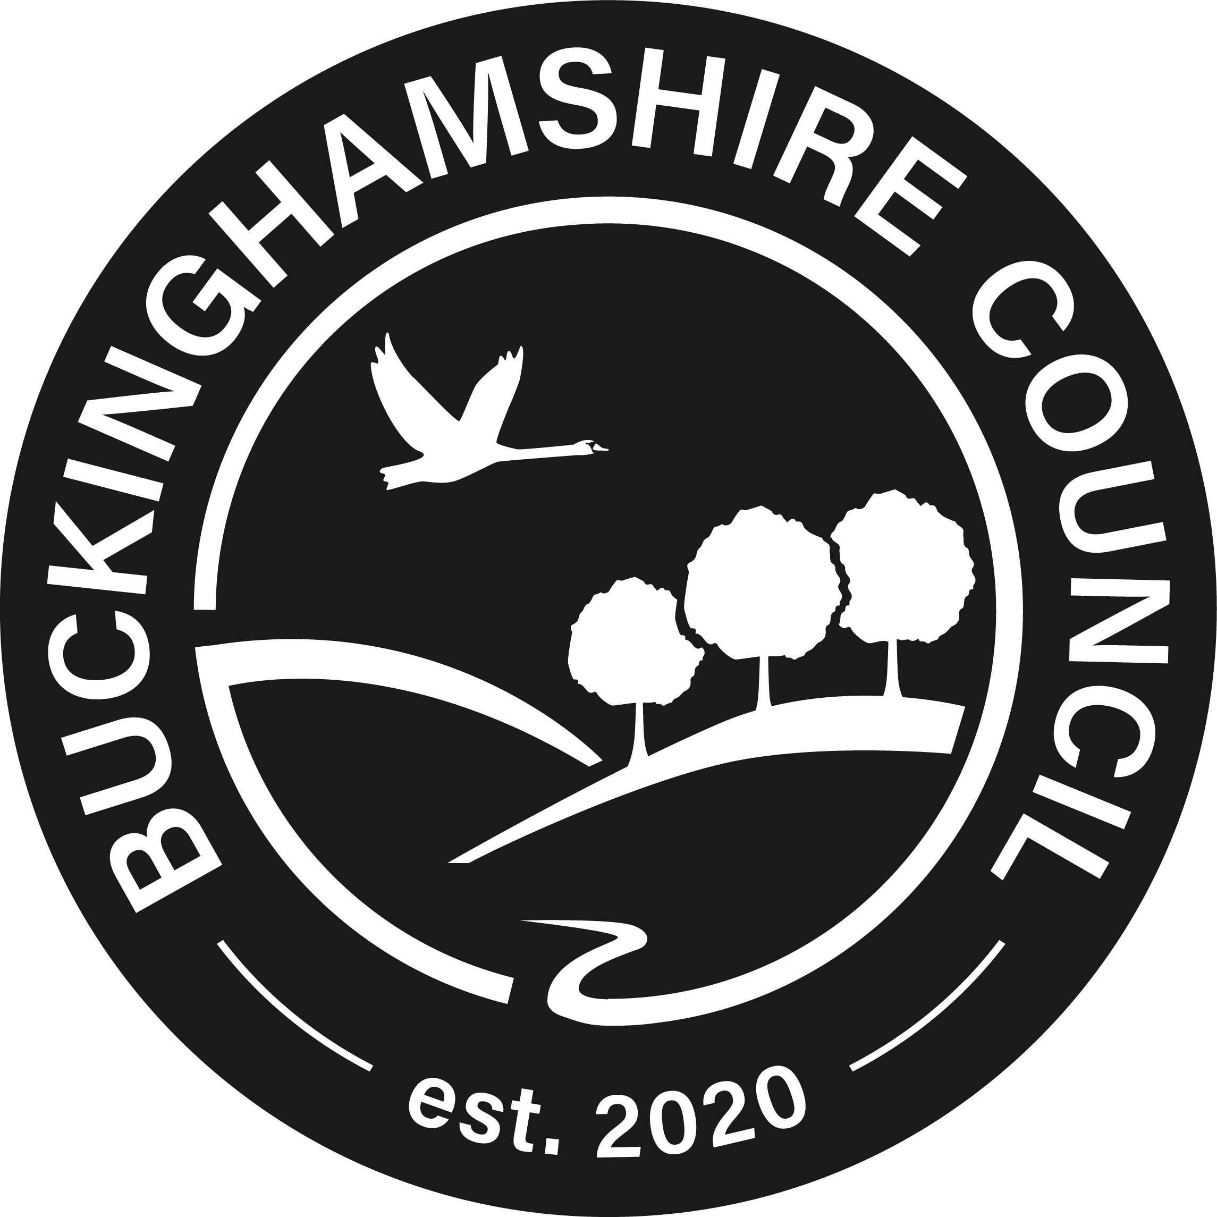
www.discoverbucksmuseum.org

