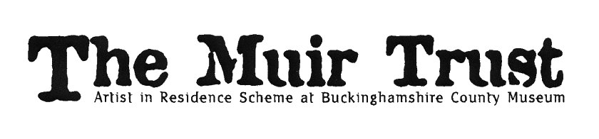
muirtrust.org.uk
The Muir Trust Artist in Residence 2024 – Application
Drawing portraits
Media: non-digital 2D drawing media
Deadline for applications: noon on Friday 5 January 2024
Shortlisting: Monday 22 January 2024
Interview: Tuesday 6 February 2024
Residency award: £3,000 (plus up to £1,000 expenses)
Residency dates: during period 8 April – 10 May 2024 (20 days of residency on site)
Residency exhibition: opening 25 May, closing 29 June 2024 (selling exhibition)
We are looking for an established artist to draw portraits using their choice of (non-digital) 2D drawing media.
The artist will produce an assemblage of drawn portraits - evoked by people within the museum and the surrounding area - which will resonate with our visitors from Buckinghamshire and beyond.
Applications should be clear, concise and inspiring.
As well as completing the application form, please attach
- an up-to-date CV
- up to eight images (max size 1MB) each with title and date of the piece, and materials
The deadline for applications is noon on Friday 5 January 2024.
On 22 January 2024, we will shortlist up to four applicants.
The shortlisted artists will be invited to the museum on Tuesday 6 February 2024. They will individually meet the selection panel, to discuss their work, their experience and their ideas about the residency; and to show examples of their recent work.
The panel will select one artist who will be offered the residency, subject to satisfactory references.
We are unable to provide feedback to unsuccessful applicants.

Completed application forms should be emailed to:
Melanie Czapski, Keeper of Art mczapski@discoverbucksmuseum.org

Discover Bucks Museum
Church Street
Aylesbury HP20 2QP
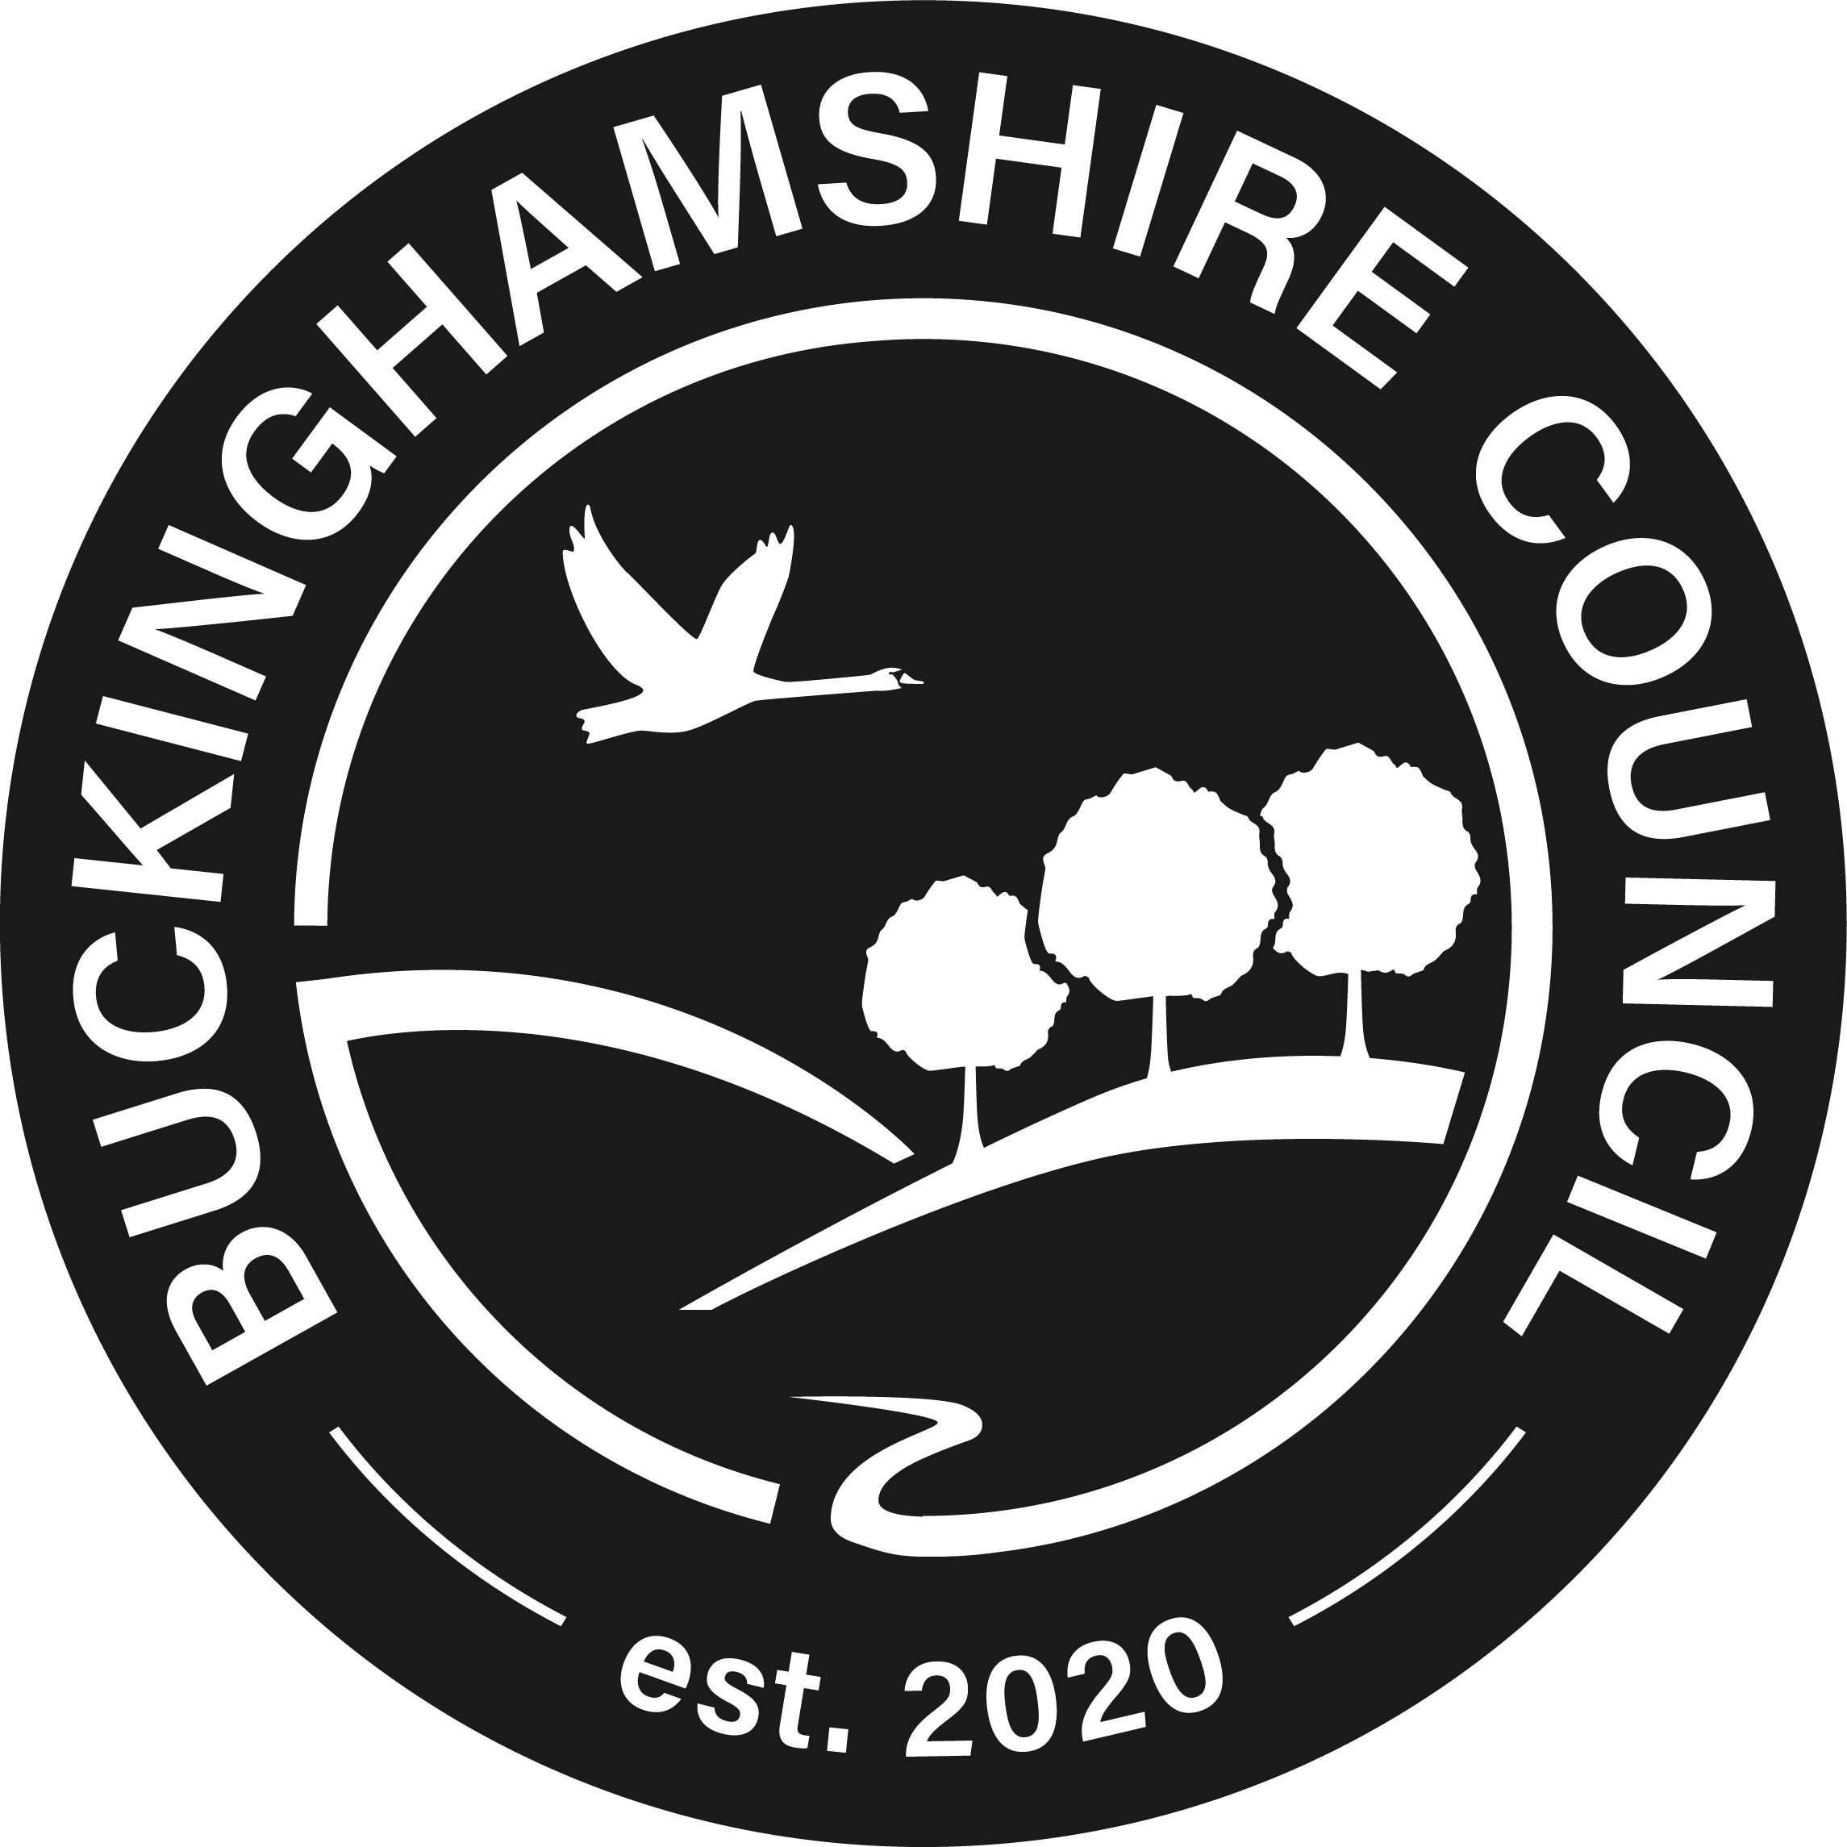
www.discoverbucksmuseum.org
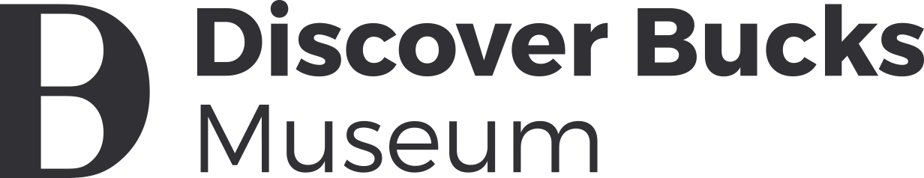
The Muir Trust Artist in Residence 2024 – Application
Name
Address
Telephone
email
Reference (1): name
email
relationship to applicant
Reference (2): name
email
relationship to applicant
(a)
How do you propose to approach drawing portraits during the residency?
(up to 75 words)
(b)
How might your response develop, in your choice of
2D drawing media?
(up to 75 words)
(c)
What experience do you already have of working in a community or educational setting?
(up to 100 words)
(d)
How would you engage with visitors in the museum throughout the residency?
(up to 100 words)
(e)
What is your current visual art practice?
(up to 100 words)
(f)
How might this residency be an opportunity for you to develop your practice in new directions?
(up to 100 words)
Any other information?
(up to 75 words)
Please sign and date: | I confirm I have the legal right to work in the UK.
Thank you for completing the application form.
Please don’t forget to attach
- an up-to-date CV
- up to eight images (max size 1MB) each with title and date of the piece, and materials.
In accordance with the 2018 Data Protection Act, Bucks County Museum Trust (BCMT) is committed to protecting your privacy. We may hold and use personal information for personnel reasons and to enable the organization to keep in touch during your application. This information may be stored in both manual and computer form and will be destroyed when no longer required. For further information please see: www.discoverbucksmuseum.org/privacy-policy/

