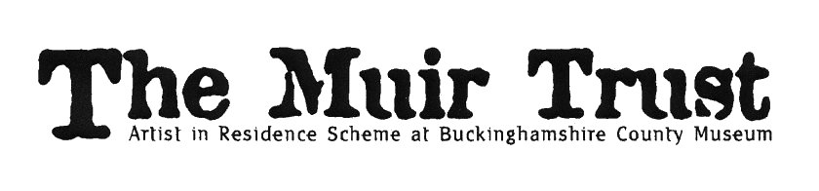
muirtrust.org.uk
The Muir Trust Artist in Residence 2022 – Application
Theme: “Printing the Museum”
Medium: Print media
Deadline for applications: noon on 30 November 2021
Shortlisting: 16 December 2021
Interview: 6 January 2022
Residency award: £3,000 (plus up to £1,000 expenses)
Residency dates: during period 11 April – 21 May 2022 (20 day residency)
Residency exhibition: opens 28 May, closes 2 July 2022 (selling exhibition)
We are looking for a visual artist-printmaker to respond to the theme “Printing the Museum”, using print media, who fulfills all of the key requirements.
Applications should be clear, concise and inspiring.
As well as completing the application form, please attach
- an up-to-date CV
- up to eight images (max size 1MB) each with title and date of the piece, and materials
The deadline for applications is noon on 30 November 2021.
On 16 December 2021, we will shortlist four applicants.
The four shortlisted artists will be invited to the museum on 6 January 2022. They will individually meet the selection panel, to discuss their work, their experience and their ideas about the residency; and to show examples of their recent work.
The panel will select one artist who will be offered the residency, subject to satisfactory references.
We are unable to provide feedback to unsuccessful applicants.

Completed application forms should be emailed to:
Melanie Czapski, Curator of Art mczapski@discoverbucksmuseum.org

Discover Bucks Museum (formerly Bucks County Museum)
Church Street
Aylesbury HP20 2QP
www.discoverbucksmuseum.org
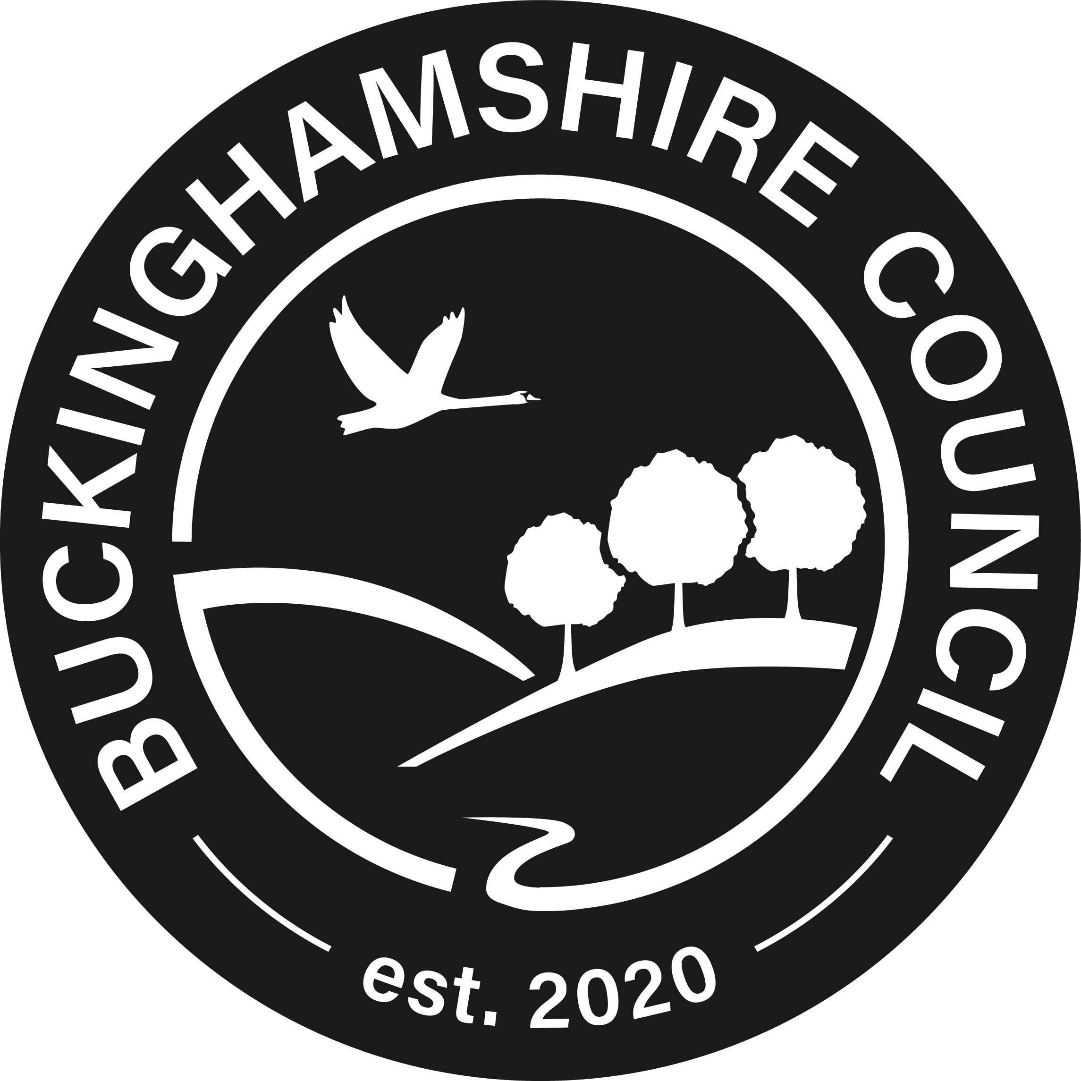
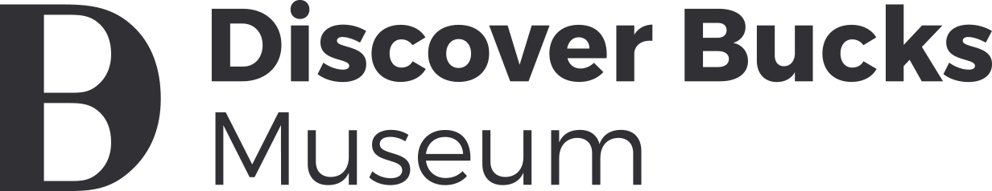

The Muir Trust Artist in Residence 2022 – Application
Name
Address
Telephone
email
Reference (1): name
email
relationship to applicant
Reference (2): name
email
relationship to applicant
(a)
Why do you want to respond to the theme of
“Printing the Museum”?
(up to 70 words)
(b)
How might your response develop, in your choice of
print media?
(up to 70 words)
(c)
What experience have you of work in a community or educational setting?
(up to 100 words)
(d)
How would you engage with visitors in the museum throughout the residency?
(up to 100 words)
(e)
What is your current visual art practice?
(up to 100 words)
(f)
How might this residency be an opportunity for you to develop your practice in new directions?
(up to 100 words)
Any other information?
(up to 75 words)
Please sign & date | I confirm I have the legal right to work in the UK.
Thank you for completing the application form.
Please don’t forget to attach
- an up-to-date CV
- up to eight images (max size 1MB) each with title and date of the piece, and materials.
In accordance with the 2018 Data Protection Act, Bucks County Museum Trust (BCMT) is committed to protecting your privacy. We may hold and use personal information for personnel reasons and to enable the organization to keep in touch during your application. This information may be stored in both manual and computer form and will be destroyed when no longer required. For further information please see: www.discoverbucksmuseum.org/privacy-policy/

